Artist Statement for Jan Soules 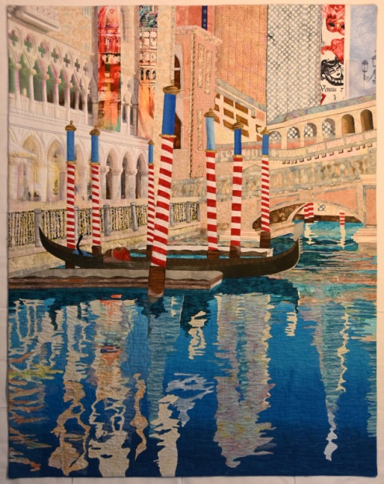
Color plays an important role in my creative process. I enjoy mixing my fabric color palette as an artist mixes his paints. Much of my work is composed of pictorial pieces, inspired by my ten years living abroad in Spain, France, Germany and Taiwan. I currently reside in Northern California in the small city of Elk Grove. I am only 20 minutes from our state capitol, Sacramento and San Francisco is about 1 ½ hours away, depending on traffic.
I start with my own photos, create a pattern and interpret it, as it suits the composition. I often combine piecing and fusing in one piece and enjoy adding unexpected photo transfers. Many of my own hand dyes end up in my work, often mixed with those of others and commercial fabrics. I recently completed a five day workshop with Pat Pauly, dying many pieces of wonderful fabrics which will undoubtedly be used in my upcoming work.
I usually work on several projects at a time, all at different stages. This gives me the flexibility of choosing what suits my mood on any given day. I recently began exploring improvisational piecing using solid fabrics. This is a new departure for me, but one I am excited about pursuing seriously in the future.
My desire is that my finished compositions draw you in and bring back fond memories of places you have been or places you wish to visit! We can all enjoy a good escape!

